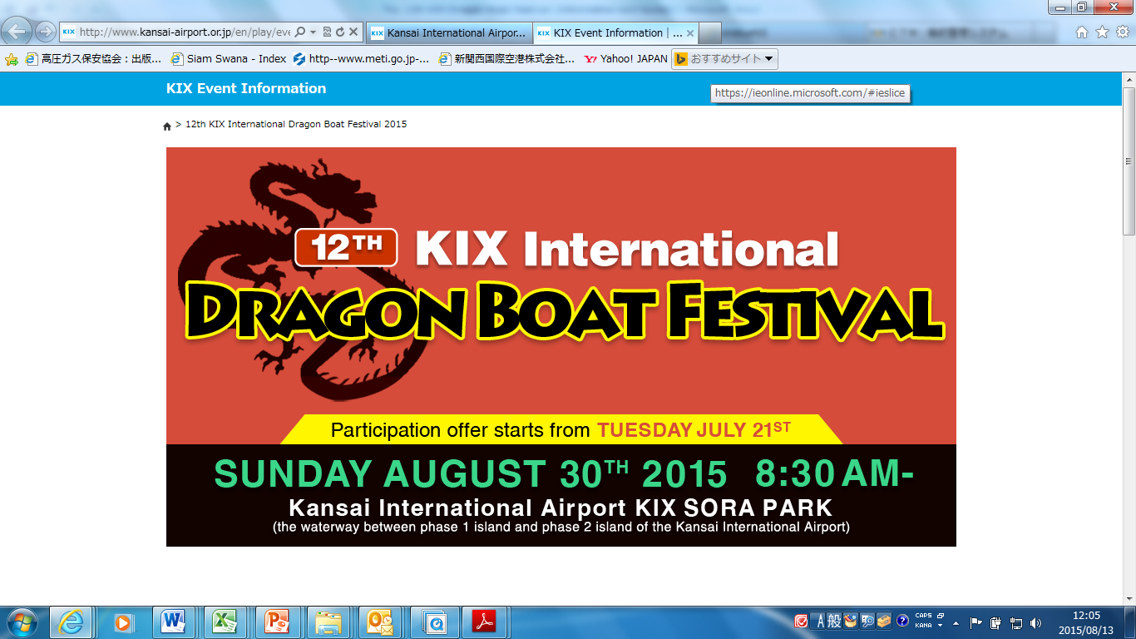

14th

Information and Guide

Contact Info

*Kazuya NAKAMURA

KIX Dragon Boat Festival Committee

TEL: +81-73-428-1431

+81-90-1890-9394 (Available on August27th & 28th)

E-mail: dragon2016@wbs.co.jp

Practice session, August 26th

● Date: 26/8/2017(sat)

Each team may practice for one hour during 13:00 and 16:00.

You must board and get off the boat in this one hour.

● Venue: Regatta course is located between runway No. 1 and No.2 within the premises of the airport.

● Access: The venue is 5 minutes’ walk from the Terminal 2.

There is no coach service for the participants on practice day. Although there is a free coach service to Terminal 2. We appreciate your cooperation on using this bus on practice day. The bus leaves from 1st floor of the Aero Plaza, taking around 8 minutes to Terminal 2.

※There will be a free coach service available for the race participants on race day.

● Teams are requested to proceed to the information tent at least 10 minutes prior to the expected practice time.

● Teams are requested to prepare drinks by themselves at the time of practice.

● Tents for changing into your uniforms are arranged by the organizer near the information tent.

● It is mandatory to wear floating vests even during the practice. Floating vests are prepared at the practice site by the organizer.

● Teams are able to request steerers if they need them on practice and/or race day.

● If you are not at the venue by the time of starting, you might not be able to practice.

● All teams are requested to follow the instruction of the officials in charge.

● Any inquiry on the practice could be contacted to Mr. Nakamura (81-90-5360-6379).

The 14th KIX Dragon Boat Festival, August 27 th

◆Date & Time: Sunday, August 27th, 7:00 ~ 17:30

* Safety precaution: Following Opening Ceremony on August27 th, 8:30 ~

(No Team Managers’ Meeting for the 14th KIX Dragon Boat Festival. Race pairing is made rightly by the organizer in advance.)

◆Venue: Specially arranged 250m regatta course between runway No.1 and No.2 within the premises of the airport.

◆Race category: 1)Open 2) Mixed

◆Schedule: 08:00 Open to teams’ entry.

08:15 Teams racing 1st and 2nd heat are requested to get on board.

08:30 Opening ceremony, Eye-dotting ceremony

And Safety precaution.

09:00 Races: 1) Mixed, 2) Open

16:30 End of the races

17:00 Award ceremony

＊ We kindly request you to attend the Opening ceremony, the Eye-dotting ceremony and the Award ceremony.

**Special Attention**

● Even though drinks are arranged by the organizer at the race site, all teams are requested to prepare for themselves.

● Alcohol is strictly prohibited during the race from the view point of safety. Teams violated this rule will be disqualified.

● Each team will be provided with 2 garbage bags, and you are requested to carry your own bags back to the information desk when you leave the venue. Please do not leave them at your tent.

Access to the Racing venue

The Racing venue is 5 minutes’ walk from the Terminal 2.

Free coach service for DB festival is available from the bus terminal (1st floor of the Aero Plaza) to Terminal 2. It takes about 8 minutes.

○ Bus schedule

From 7:00 - 9:00 every 5 – 8 minutes

From 9:00 - 18:00 every 20 minutes

○ Attention

There are free coaches for

1) KIX Dragon Boat Festival Participants

2) Terminal 2 (Peach Aviation) Passengers

Please take the free coach service for the Dragon Boat Festival participants, and it’s appreciated not to take the free coach service for Peach Passenger. Also, many passengers & athletes are expected to use the free coaches, please make sure to be well prepared. Thank you for your cooperation.

○ Bus terminal

**Aero Plaza(Hotel)**



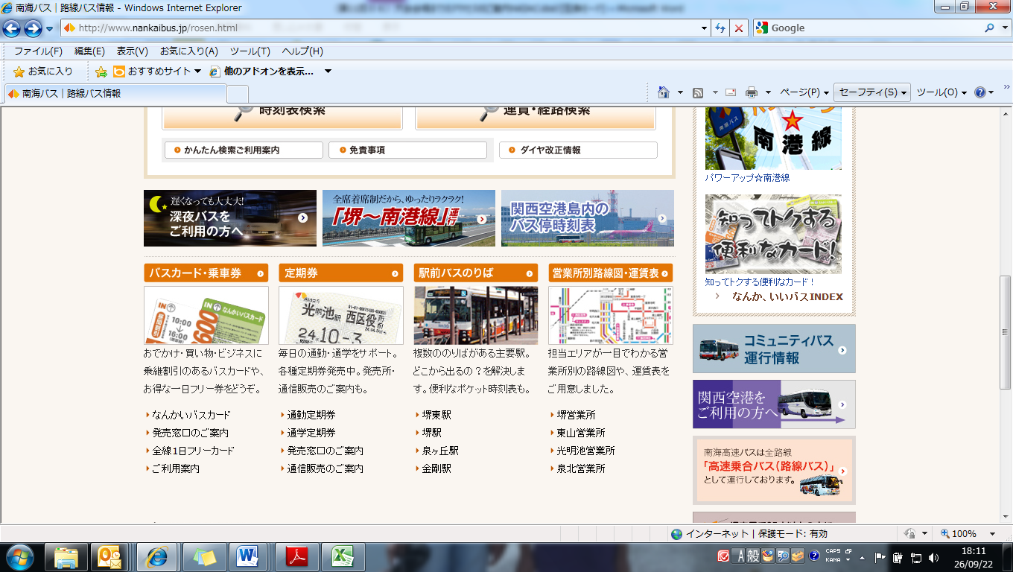

**Bus Stop**

**The Terminal 2F**

**Airport Station**

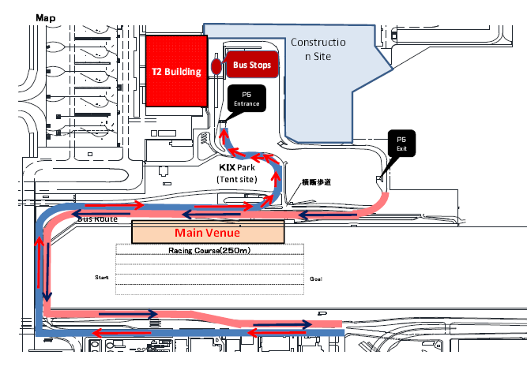

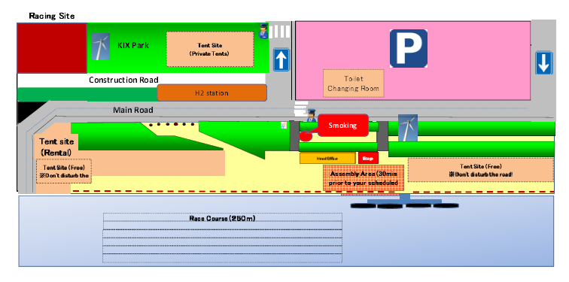

Attentions to be paid at the venue

○Please keep in mind that races are held within the premises of the airport and you are requested to pay the following attentions.

- Be careful NOT to enter the restricted or keep out area.

- Fishing is strictly prohibited by the Osaka prefectural law. Teams violated this law shall be disqualified.

-The use of fire, such as BBQ is strictly prohibited at any place of the venue and the park tent site). Smoking is not allowed except for the designated smoking areas.

-Please understand that you may NOT use soap or shampoo at the shower site.

-Alcohol is strictly prohibited during the races from the view point of safety. Teams violated this rule shall be disqualified.

Information

○You are advised to take leisure sheets or chairs if possible, because the ground is not flat.

○The place for changing into your uniform are arranged by the organizer.

○Even though drinks are arranged and provided by the organizer at the race site, all teams are well advised to prepare drinks for themselves. You can purchase drinks at the convenience stores near the hotel and in the terminal building.

○Lunch boxes will be provided (only teams requested in advance) at the reception desk from 11:00. Please come to the desk with 3 or 4 people from each team.

○Each team will be provided with 2 garbage bags and you are requested to carry your garbage bags back to the information desk when you leave the venue. Don’t leave them at your tent.